LEMBAR KERJA PESERTA DIDIK
PRAKTIKUM PERHITUNGAN VLSM

Nama Kelompok
- ………………….
- …………………..

Topologi Perhitungan VLSM
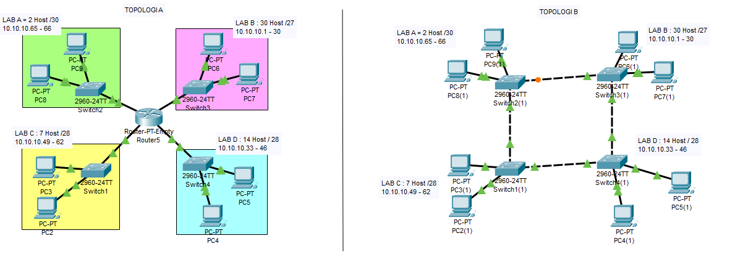

- Tabel Perhitungan VLSM

NAMA LAB | NA | RHA awal | RHA Akhir | BA | Subnetmask

- TOPOLOGI A

Hasil Ping PC Client LAB A ke LAB B

Screenshot Hasil Praktikum

Hasil Ping PC Client LAB B ke LAB C

Screenshot Hasil Praktikum

Hasil Ping PC Client LAB C ke LAB D

Screenshot Hasil Praktikum

Hasil Ping PC Client LAB A ke LAB D

Screenshot Hasil Praktikum

Kesimpulan Topologi A :

……………………………………………………………………………………………………
……………………………………………………………………………………………………
……………………………………………………………………………………………………
……………………………………………………………………………………………………

- TOPOLOGI B

Hasil Ping PC Client LAB A ke LAB B

Screenshot Hasil Praktikum

Hasil Ping PC Client LAB B ke LAB C

Screenshot Hasil Praktikum

Hasil Ping PC Client LAB C ke LAB D

Screenshot Hasil Praktikum

Hasil Ping PC Client LAB A ke LAB D

Screenshot Hasil Praktikum

Kesimpulan Topologi B :
……………………………………………………………………………………………………
……………………………………………………………………………………………………
……………………………………………………………………………………………………

Jelaskan Istilah ini yang muncul saat kamu melakukan troubleshooting PING ?
- Reply from [Alamat IP]: Bytes, Time, TTL
………………………………………………………………………………………………………………………………………………………………………………………………………………………………………………………………………………………………
- Request Timed Out (RTO)
………………………………………………………………………………………………
………………………………………………………………………………………………Penyebab
………………………………………………………………………………………………
………………………………………………………………………………………………Gejala …………………………………………………………………………………………………………

- Destination Host Unreachable
………………………………………………………………………………………………………………………………………………………………………………………………
Penyebab ………………………………………………………………………………………………

- General Failure
………………………………………………………………………………………………
………………………………………………………………………………………………Penyebab
………………………………………………………………………………………………

