LKPD ROUTER STATIC 3 ROUTER
PRAKTIKUM ROUTING STATIC 3 ROUTER

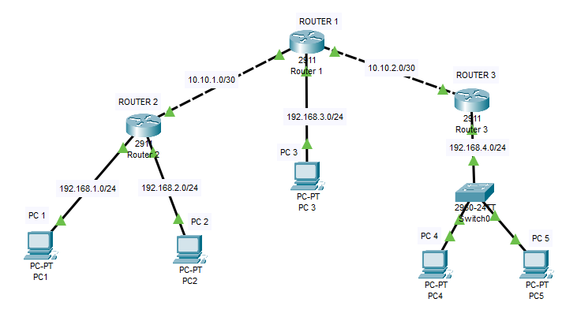

Instructions
- Buat Kelompok 1 kelompok 4 siswa
- Buat topologi diatas menggunakan packet tracert dan konfigurasikan ip address dan routing static di topologi diatas supaya masing masing pc client router bias saling terhubung
- Uji coba atau tes ping antara PC client masing masing router
- Catat ip address di tabel address dan konfigurasinya yang sudah di sediakan

Tabel Address
Device | Interface | IP Address | Subnet Mask | Default Gateway
Building1 | G0/0 | blank | blank | N/A
Router 1 | G0/1 | blank | blank | N/A
Building1
Building2 | G0/0 | blank | blank | N/A
Router 2 | G0/1 | blank | blank | N/A
Building2
Router 3 | G0/0 |  |  | N/A
Router 3 | G0/1 |  |  | N/A
PC 1 | NIC | blank | blank | blank
PC 2 | NIC | blank | blank | blank
PC 3 | NIC | blank | blank | blank
PC 4 | NIC | blank | blank | blank
PC 5 | NIC

- KONFIGURASI ROUTER 1

- Config Ip address

(ketikan/copy Perintah config CLI nya/Screenshot)

- Config Routing static

(ketikan/copy Perintah config CLI nya/Screenshot)

- KONFIGURASI ROUTER 2

- Config Ip address

(ketikan/copy Perintah config CLI nya/Screenshot)

- Konfig Routing static

(ketikan/copy Perintah config CLI nya/Screenshot)

- KONFIGURASI ROUTER 3

- Config Ip address

(ketikan/copy Perintah config CLI nya/Screenshot)

- Config Routing static

(ketikan/copy Perintah config CLI nya/Screenshot)

